**Project 3 - Publishing Amazon SNS Messages Privately**

**Industry**: Healthcare

**Problem Statement:** How to secure patient records online and send it privately to the intended party

**Topics:** In this project, you will be working on a hospital project to send reports online and develop a platform so the patients can access the reports via mobile and push notifications. You will publish the report to an Amazon SNS keeping it secure and private. Your message will be hosted on an EC2 instance within your Amazon VPC. By publishing the messages privately, you can improve the message delivery and receipt through Amazon SNS.

**Highlights:**

1. AWS CloudFormation to create a VPC

2. Connect VPC with AWS SNS

3. Publish message privately with SNS

**AWS CloudFormation to create a VPC**

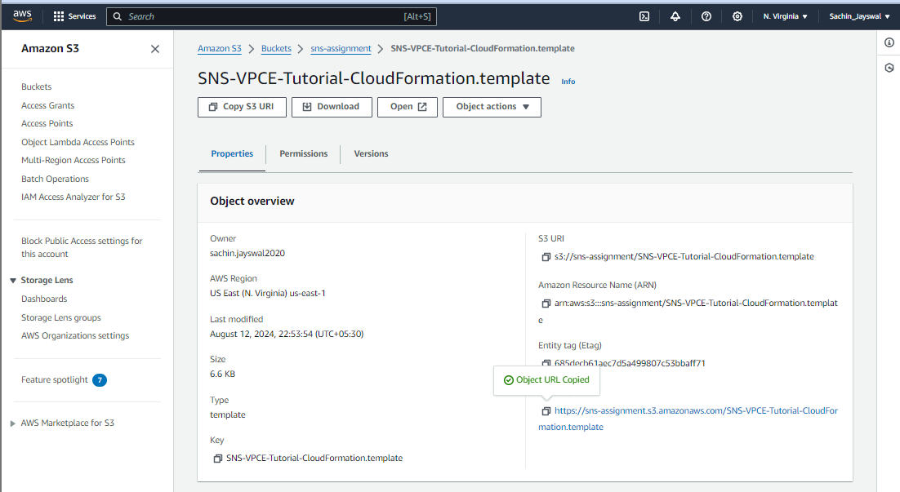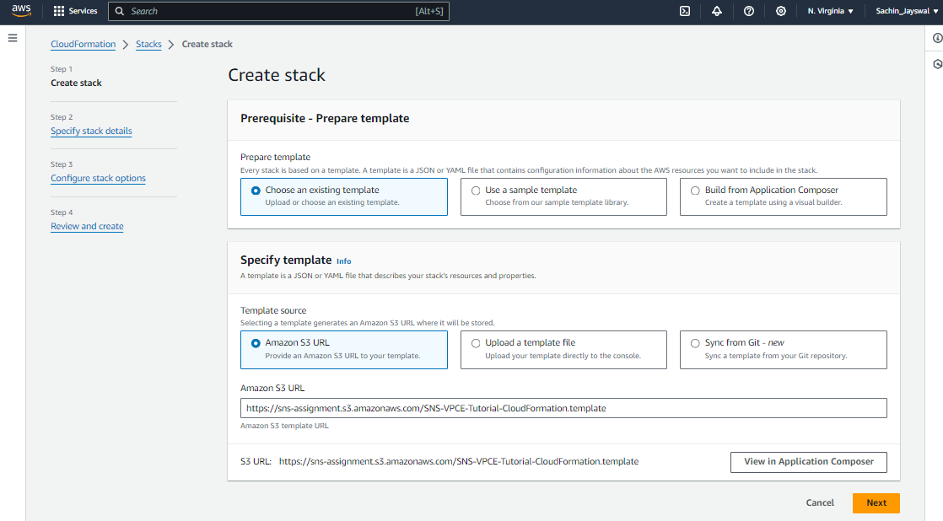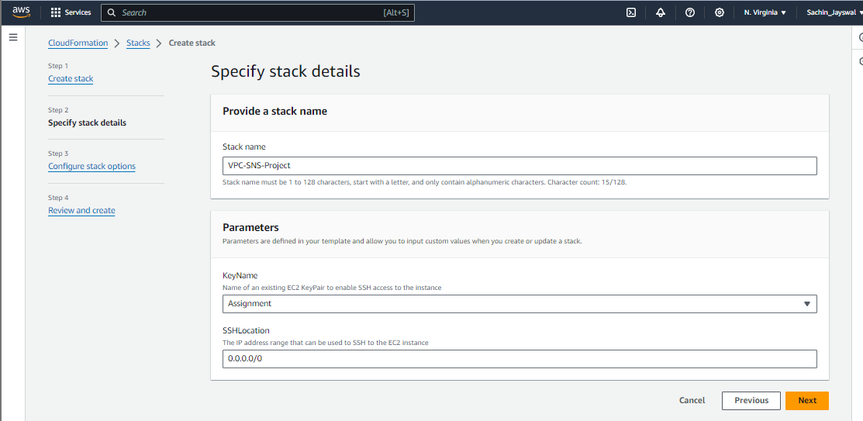

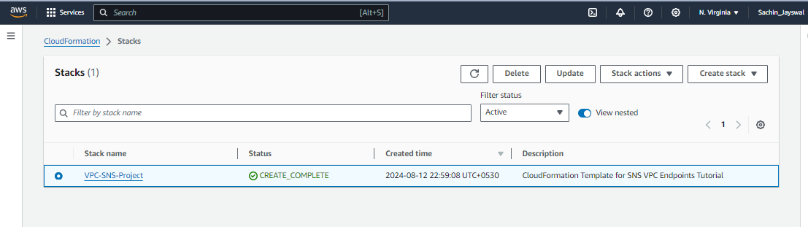

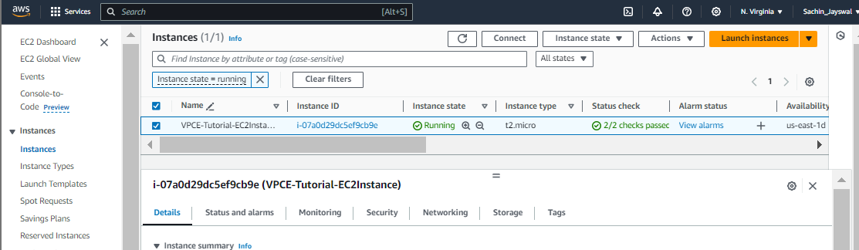

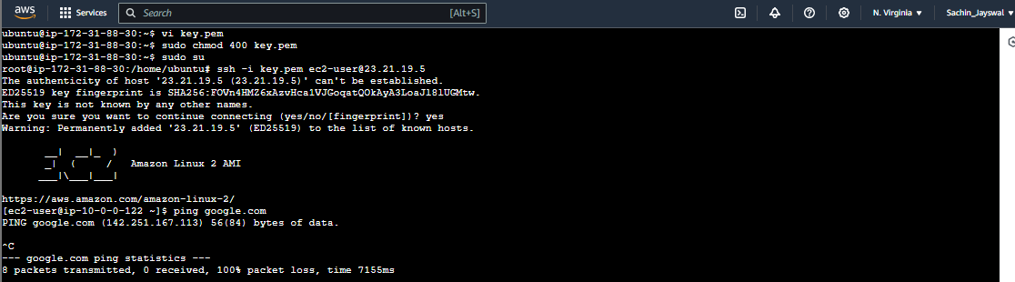

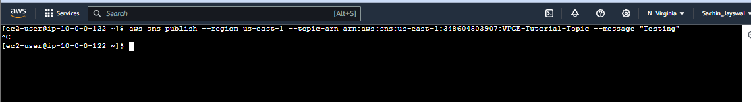

**Connect VPC with AWS SNS**

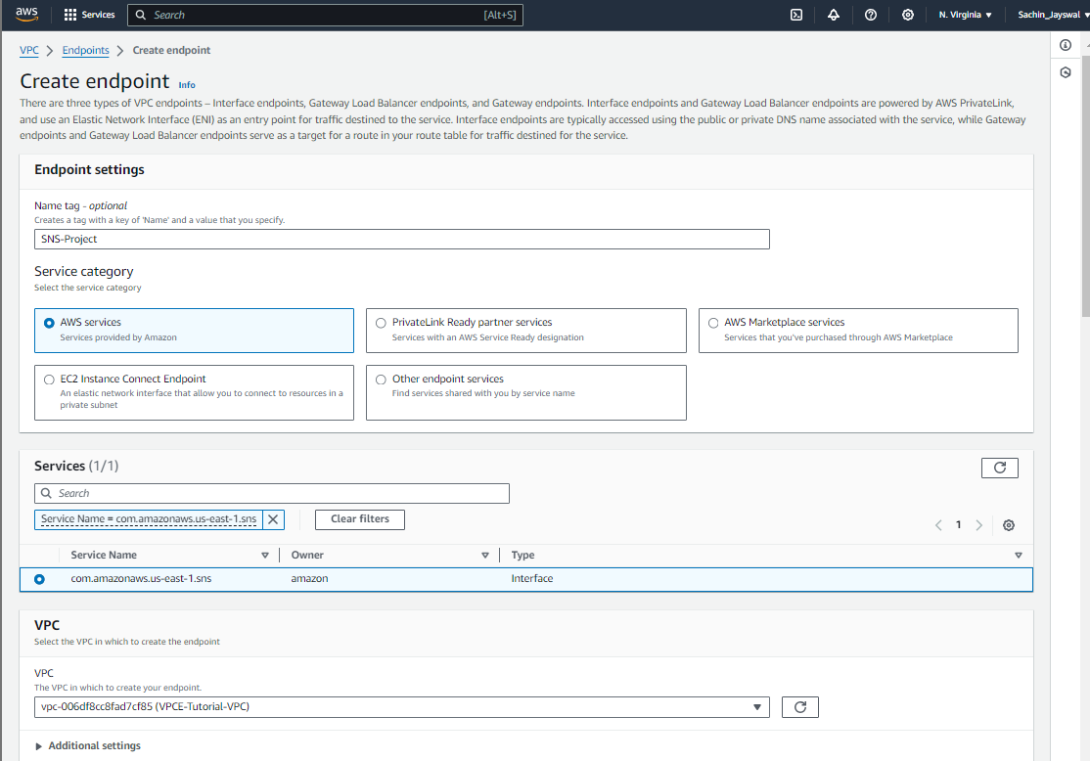

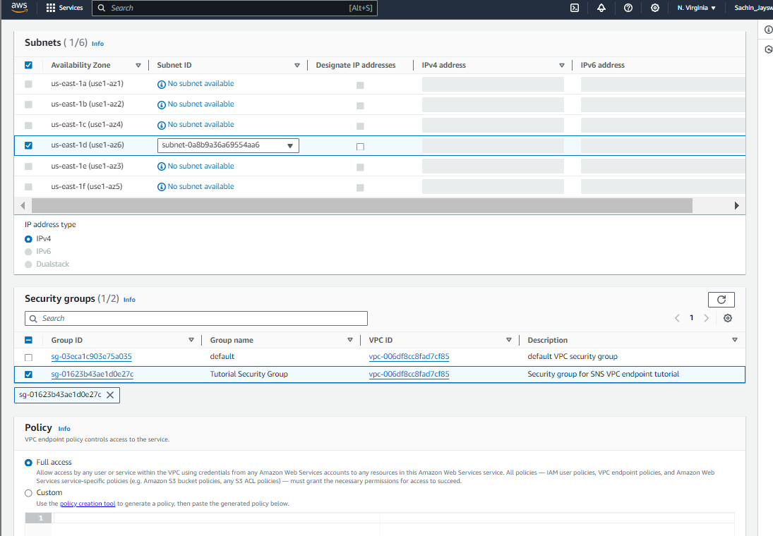

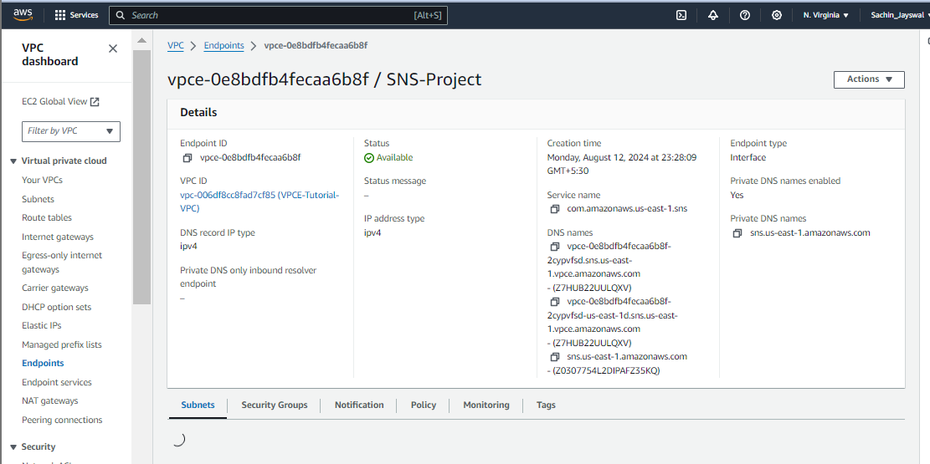

**Publish message privately with SNS**

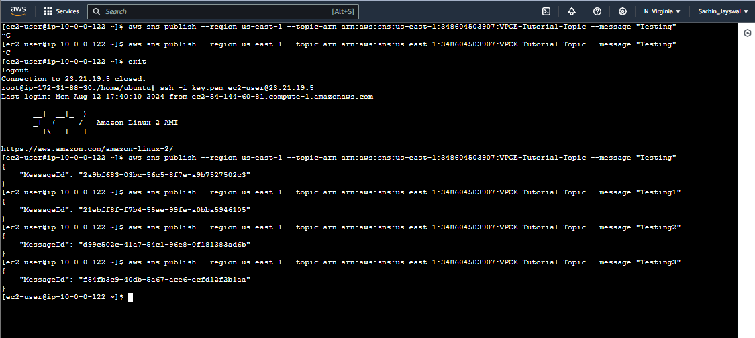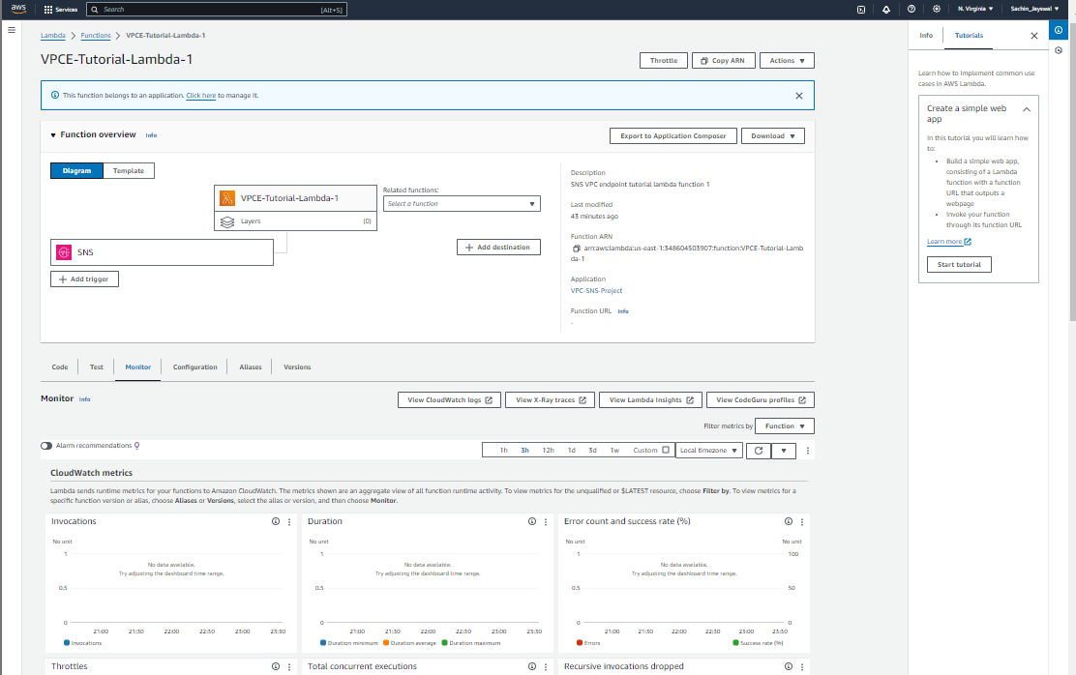

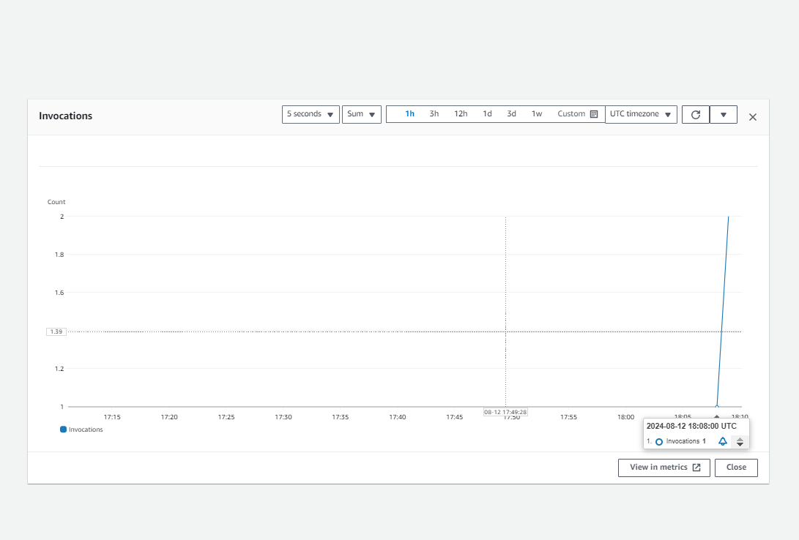

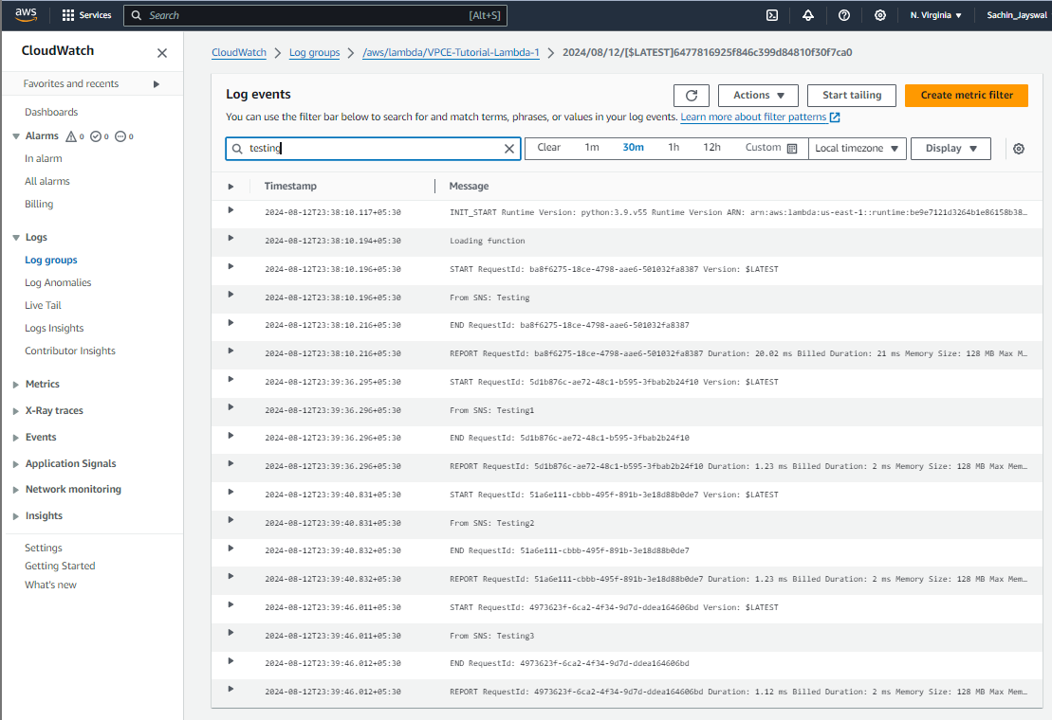

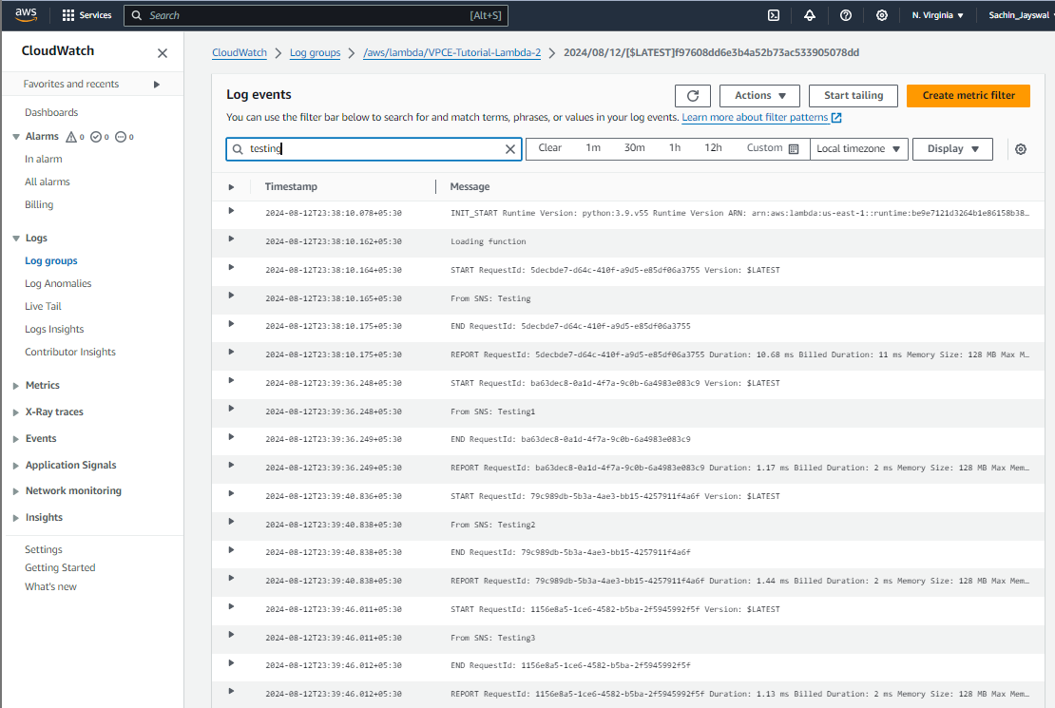

Sachin Jaiswal